*ALMP fleet managemenT*

Business Case

|  |  |
| --- | --- |
| Business Case | |
| Project Title | *ALMP Fleet managemenT* |
| Project Sponsor | Ramandeep Singh Virdi |
| Project Manager: | Arman Singh |
| Technical Manager: | Vinod Kumar Tiwari |
| Project Owner: | Dheeraj Pant |

**Document Control**

|  |  |  |  |  |  |
| --- | --- | --- | --- | --- | --- |
| Version No. | Date | Author | Change History | Reviewed By | Approved By |
|  |  |  |  |  |  |
| V 0.0.1 | 12-10-2023 | Vinod Kumar Tiwari |  |  |  |

Contents

1. Executive Summary 4

2. Project Description 4

3. Benefits, Goals and Measurement Criteria 5

4. Delivery Cost and Budget 6

5. ROI and Compliance Benefits **Error! Bookmark not defined.**

6. Assumptions 7

# ExECUTIVE SUMMARY

ALMP integrated end to end transparency & control on direct and indirect maintenance cost and fleet downtime losses will be the next innovative fleet management solution to improve productivity and reduction in cost by making the effective utilization of drivers and the available vehicles by integrating with the smart devices which can help in real time vehicle data tracking with Americana Last Mile Platform (ALMP) services to achieve the following set of business goals:

* Driving Behavior Assessment
* Crash Alerts
* Training Requirement for Safe Driving
* On-trip & off-trip Monitoring
* Green Points Strategy for Riders
* Assets Utilization

# PROJECT DESCRIPTION

ALMP with an integration approach and fleet management will be helping in reduction of the run cost for drivers and vehicles with Americana Last Mile Platform product to achieve more efficient utilization of riders and vehicles to optimize journey and order delivery experience.

* Automate Feedback for Drivers based on Driver Behavior Assessment
  + Performance Report
  + Driver Training
  + Prevent unsafe driving.
  + Driver Management
* Crash Alert
  + Over Speed Alarm
  + Accident Alerts
  + SMS Alerts
* Optimize Fleet Delivery Routes with On-trip & off-trip Monitoring.
  + Fleet live tracking
  + Geo fencing
  + Route allocation

# Benefits Goals and Measurement criteria

With ALMP fleet service operations profitability with technology solutions will be 360-degree improvements.

**Core Benefits**

* Improved workforce productivity
* Improved vehicle utilization
* Improved maintenance management
* Reduction in fuel and vehicle theft
* Reduced vehicle downtime
* Reduction repair cost
* Reduction in vehicle failures

**Value Matrix**

* Vehicle Tracking and Availability
* Driving Behavior Rating
* Maintenance Cost & Time Reporting
* Fuel Maintenance
* Vehicle Past Performance

**Business Intelligence**

* Driving behavior analysis
* Speed analysis
* Vehicle aging comparison.
* Vehicle maintenance cost analysis & forecasting
* Vehicle performance scoring

**Business Goal**

* Distance Travelled and advanced reporting.
* Measure and optimize fleet performance to meet business goals.
* Use real-time & historical data trends for making quantifiable business decisions.
* Cut operating expenses and improve fleet productivity.

# Delivery Cost and Budget

ALMP platform integrated fleet management solution will initially require having smart devices enablement on vehicles available with the drivers. Where with different markets we can consider the device costing with breakup marketwise cost will be as per below table:

|  |  |  |  |
| --- | --- | --- | --- |
| **Market** | **Total Drivers** | **Unit Price** | **Expected Cost ($ per year)** |
| **($ per year)** |
| Bahrain | 275 | $ 120.00 | $ 33,000.00 |
| UAE | 2,695 | $ 120.00 | $ 323,400.00 |
| Kuwait* | 1,192 | $ 120.00 | $ 143,040.00 |
| Egypt* | 1,601 | $ 120.00 | $ 192,120.00 |
| Oman | 21 | $ 120.00 | $ 2,520.00 |
| Qatar | 420 | $ 120.00 | $ 50,400.00 |
| KSA | 157 | $ 120.00 | $ 18,840.00 |
|  |  |  |  |
| **Estimated Total Delivery Cost** | | | **$763,320** |

* Pilot markets in FY-24

Once the vehicles will be ready with the smart GPS devices further with existing ALMP platform services needs to be integrated with the smart device provider services via real-time basis or with API based integration mechanism for that further there will be infra and licenses cost will be as per below with Capex and Opex budget with the following details:

|  |  |  |  |
| --- | --- | --- | --- |
| **Cloud Infra and Licenses Cost** | | | |
| **Environments** | **Items** | **Unit Price** | **Expected Cost ($ per year)** |
| **($ per month)** |
| DEV | ALMP CLOUD DEV ENVIRONMENT (CAPEX) | $ 2,343.09 | $ 28,117.06 |
| QA | ALMP CLOUD QA ENVIRONMENT (CAPEX) | $ 2,343.09 | $ 28,117.06 |
| UAT | ALMP CLOUD UAT ENVIRONMENT (CAPEX) | $ 3,514.63 | $ 42,175.58 |
| PROD | ALMP CLOUD PROD ENVIRONENT (OPEX) | $ 11,715.44 | $ 140,585.28 |
| DR | ALMP CLOUD DR ENVIRONMENT (OPEX) | $ 1,171.54 | $ 14,058.53 |
| Licenses & APIs | Google Maps, Monitoring, Atlassian, Confluent, API etc. (CAPEX+OPEX) | $ 6,000.00 | $ 72,000.00 |

With all the spending below will be the cost of delivery of Fleet Management System with ALMP integration scope:

|  |  |
| --- | --- |
| **Estimated Total Cost of Fleet Management System** | |
|  |  |
|  |
| Estimated Total Device Cost (per year) | $ 763,320.00 |  |
| Estimated Total ALMP Infra Cost (per year) | $ 325,053.50 |  |
| Estimated Total Rollout Cost | $ 35,000.00 |  |
|  |  |  |
| **Total Estimated Cost of Delivery** | **$ 1,123,373.50** |  |

# Savings and fleet compliance

Reaching out to the savings and considering the savings per order cost a trial was conducted with Bahrain with a store and a few drivers with careful considerations we reach out to $ 0.04 per order savings which can be calculated monthly and yearly savings as below:

|  |  |  |  |
| --- | --- | --- | --- |
| **Estimated Cost Savings Market Wise** | | | |
| **Countries** | **Savings Per Order ($)** | **Orders Per Month** | **Annual Savings in $** |
|  |
| Bahrain | 0.040 | 125,629 | $ 60,301.78 |  |
| UAE | 0.040 | 1,466,923 | $ 704,122.99 |  |
| Kuwait | 0.040 | 572,713 | $ 274,902.24 |  |
| Qatar | 0.040 | 290,265 | $ 139,327.04 |  |
| KSA | 0.040 | 313,497 | $ 150,478.32 |  |
| Egypt | 0.040 | 495,239 | $ 237,714.68 |  |
| Oman | 0.040 | 49,285 | $ 23,656.83 |  |
|  |  |  |  |  |
| **Estimated Total Cost Savings** | | | **$1,590,504** |  |

# Additional savings

In addition to above savings further the smart devices with GPS trackers will also help reduce Stolen Bikes with following:

|  |  |  |  |
| --- | --- | --- | --- |
| **Estimated Cost Savings on Vehicles Theft** | | | |
| **S. No.** | **Year of Theft** | **Total Theft** | **Estimated Vehicle Cost** |
|  |
| 1 | FY-21 | 7 | $ 91,000.00 |  |
| 2 | FY-22 | 4 | $ 52,000.00 |  |
| 3 | FY-23 | 3 | $ 39,000.00 |  |
|  |  |  |  |  |
| **Total Estimated Cost of Theft Vehicles** | | | **$ 182,000.00** |  |

# Beyond cost benefits

# Improved safety and compliance

# Reduced fuel costs

# Lower overall operational costs

# Increased productivity

# Better communication

# Assumptions

*Below is the list of assumptions made during this draft version of documentation with basic costing, budgeting, and savings can be listed in below:*

|  |  |
| --- | --- |
| **Assumption** | **Actions to validate Assumptions** |
| Microsoft Azure Cloud BoQ for Production is considered as **$11,715.44** | Validation can be done with Etisalat. |
| Monthly order volume considered from ALMP LAMDA DB with 18% order volume for 1click in October 2023 | Can be validated with the monthly order volume available in LAMDA DB for PowerBI reporting tables. |
| ALMP Dev, QA is considered 20%, UAT 30% and DR 10% of Production BoQ. | Below attached projected ALMP production BoQ component list shared via Etisalat. |

**ALMP Cloud (BoQ) Considered for infrastructure calculation:**

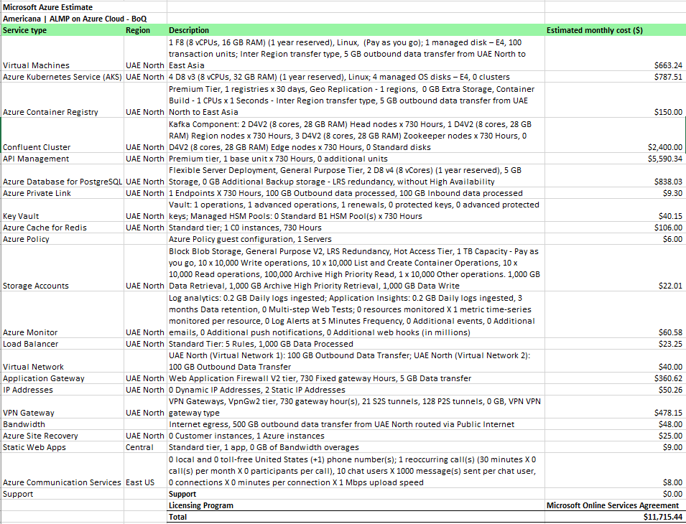

Appendix A: Business Case - Approval

The undersigned acknowledge they have reviewed the ALMP Fleet Management **Business Case** and agree with the approach it presents. Changes to this **Business Case** will be coordinated with and approved by the undersigned or their designated representatives.

|  |  |  |  |
| --- | --- | --- | --- |
| Signature: |  | Date: |  |
| Print Name: |  |  |  |
| Title: |  |  |  |
| Role: |  |  |  |

|  |  |  |  |
| --- | --- | --- | --- |
| Signature: |  | Date: |  |
| Print Name: |  |  |  |
| Title: |  |  |  |
| Role: |  |  |  |

|  |  |  |  |
| --- | --- | --- | --- |
| Signature: |  | Date: |  |
| Print Name: |  |  |  |
| Title: |  |  |  |
| Role: |  |  |  |